Spring REST using Spring Boot 3 EXERCISES O/P:

WEEK 3:
MANDATORY EXERCISES OP:
EXERCISE 1:
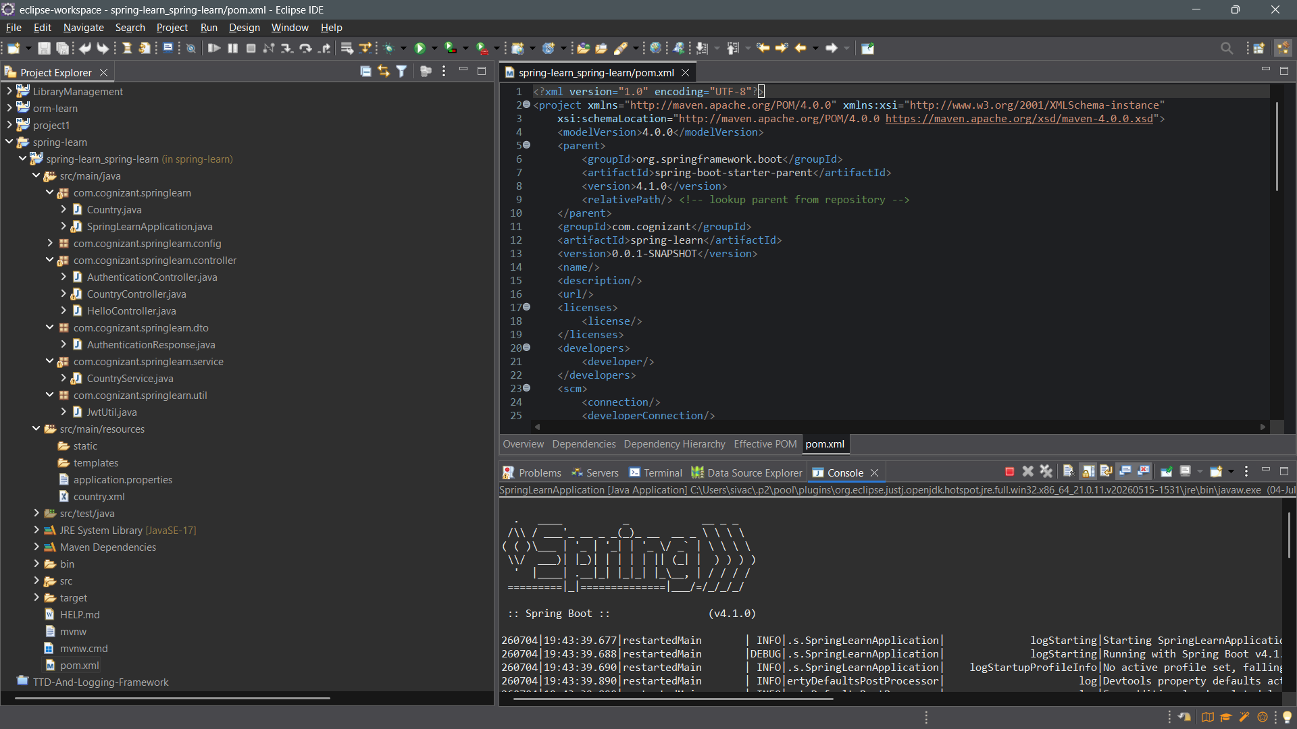

EXERCISE 2:
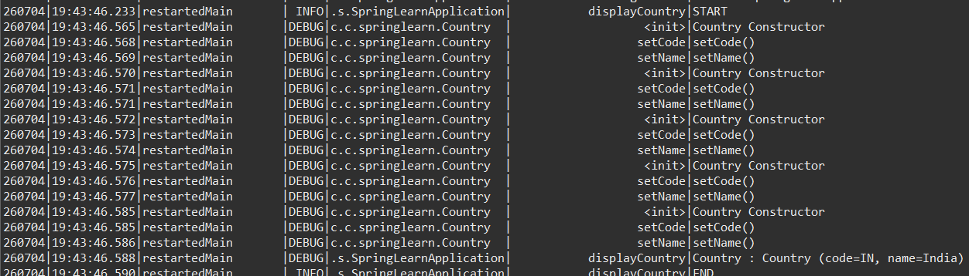

EXERCISE 3:
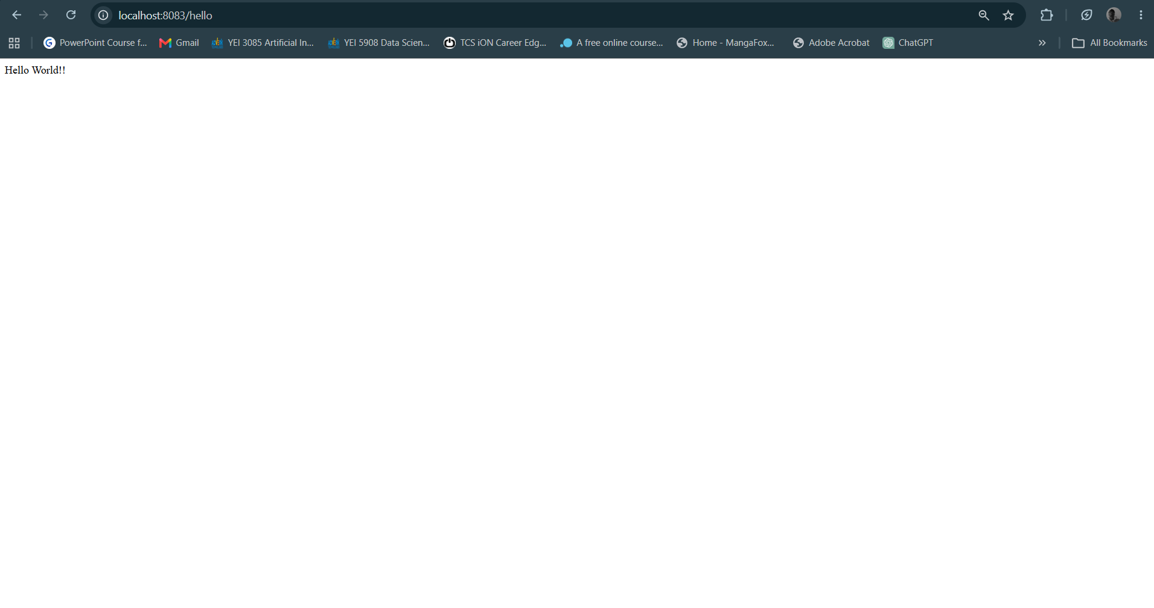
EXERCISE 4:
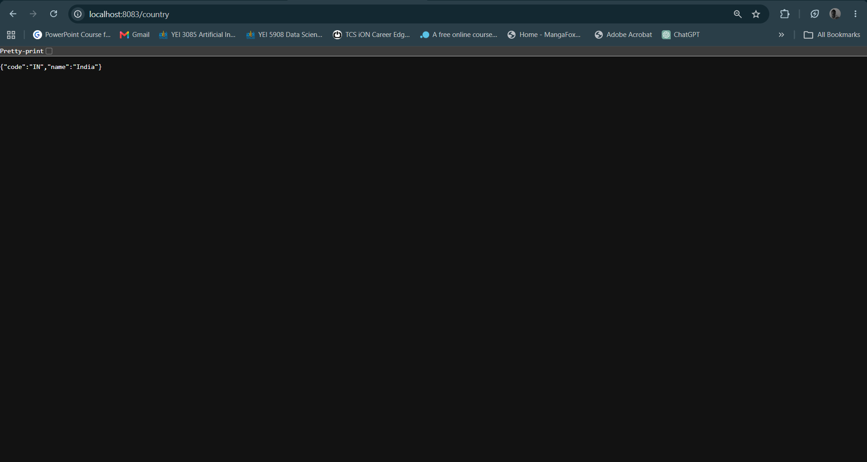

EXERCISE 5:
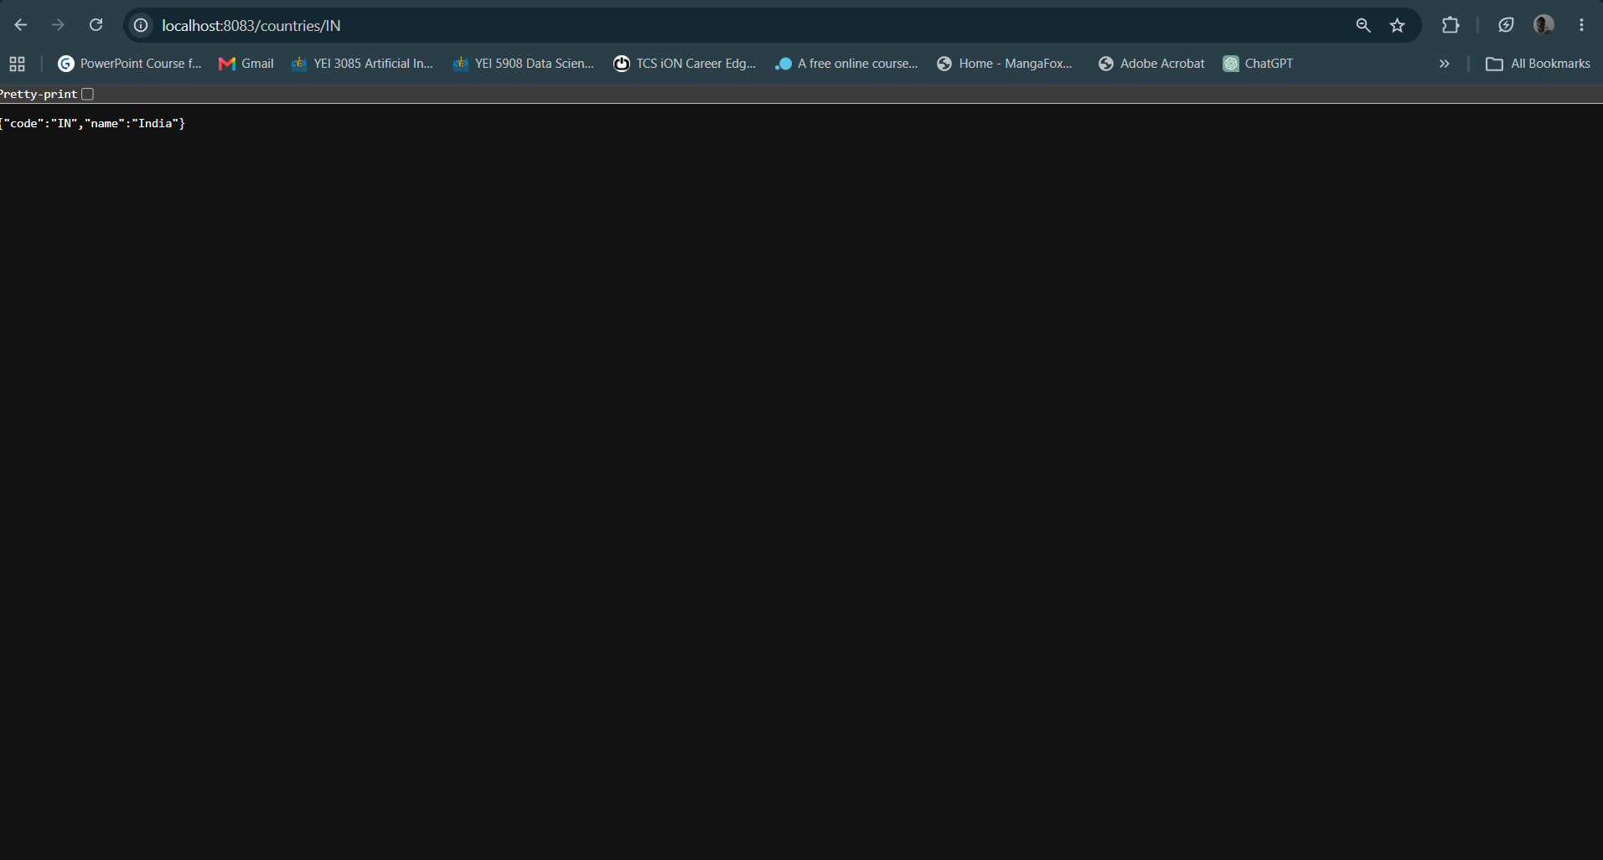

EXERCISE 6:
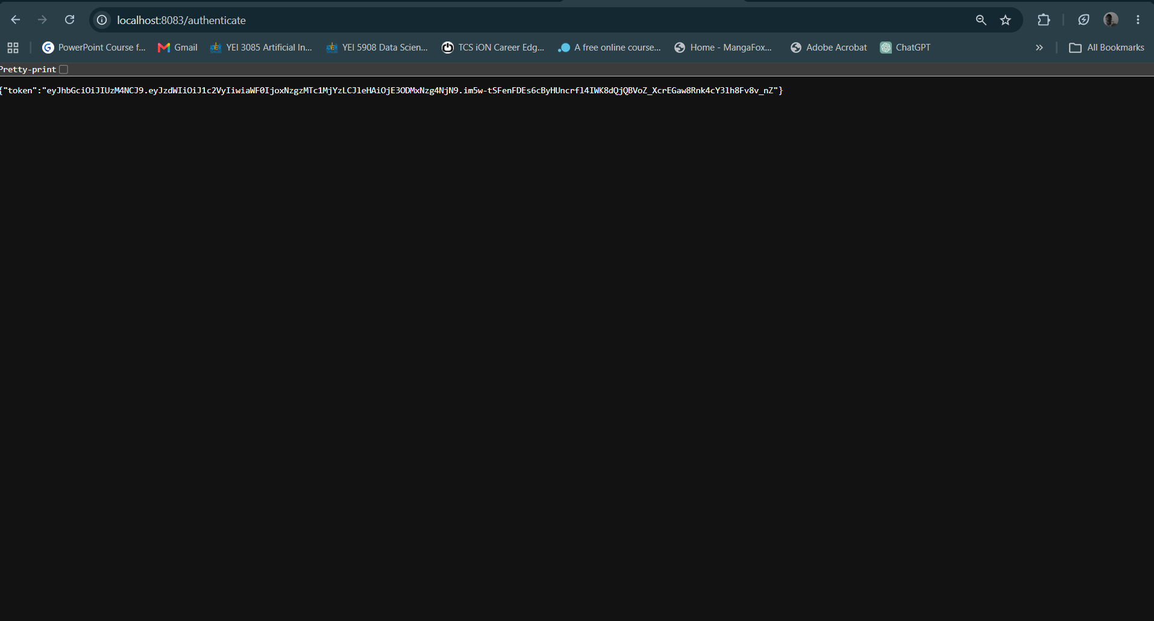

POM.XML:
